Mathias Roulleaux
Alex Goyer
Vivian Rebollo
Epitech 2023

Documentation R-TYPE:
A game engine that roars

1- Qu’est ce que le R-TYPE ?
The R-Type is a project aiming to recreate the game of the same name in CPP. The project has two main objectives:
- The first is the implementation of a network client/server that allow several people to play from different computers.
- The second and probably most important objective is the implementation of an engine for the game based on the ECS model, Entity Component System, which will be explained later in this documentation.

2- The Network

The network works with two binaries, on the one hand the server, and on the other the client(s)
At startup the client connects to the server via TCP via the ip and port given as argument.
He will then have the opportunity to create a room or join one, at which point the server will answer him what player he is (player 1, player 2, etc.).

Once in the room, the server will continuatly sends the number of players present in the room.

The creator of the room then has the possibility to tell the server if he wants to launch the game and the server transmits the information to the other clients.

Once the game is launched, the connection goes into UDP, at each turn of GameLoop, the client sends all the information necessary to display for the other client and receives the information from the other

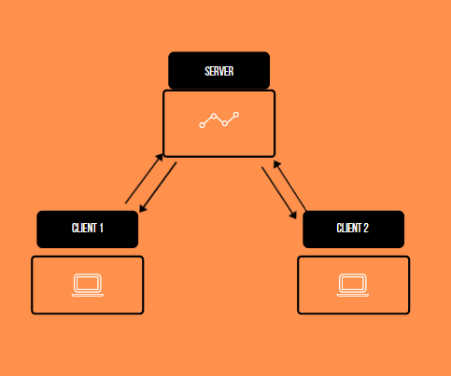

As you can see, The client cannot communicate if there is no server for sending the information.

Network Calls :

Definitions : struct gate_t : Structure used with Game Communication to structure the data that needs to be communicated. The structure is defined as :

struct gate {
RequestType type; /* 4 bytes - enum - Represents the type of the request */
unsigned int size; /* 4 bytes - uint - number of bytes to read */
unsigned int size_1; /* 4 bytes - uint - number of bytes to read in content that contains the First part : Player Position */
unsigned int size_2; /* 4 bytes - uint - number of bytes to read in content that contains the Second part : Projectile Position */
unsigned int size_3; /* 4 bytes - uint - number of bytes to read in content that contains the Second part : Enemies Position */
int content[0]; /* n*4 bytes - int - contains all position by groups of 2 int (X, Y)
example : entity position x = 100, y = 200 will be stocked in content as :
content[0] = 100, content[1] = 200.
The size of content NEEDS to be defined by size_1, size_2 and size_3.*/
}

Protocol description caption : Obligation (MUST, MUST NOT, SHOULD, etc...) - Request (if it’s the first request), Response (if it’s a request response) - Number of bytes in the request - Content of the Request

- MUST - Connection : Client - Request - TCP - 4 bytes - RequestType::CONNECTION (enum 0)
Server - Response - TCP - 4 bytes - RequestType::OK (enum 1)

- MUST - Join room : Client - Request - TCP - 4 bytes - RequestType::JOIN_ROOM (enum 3)
Server - Response - TCP - 4 bytes - RequestType::PLAYER1 (enum 4)
OR Server - Response - TCP - 4 bytes - RequestType::PLAYER2 (enum 5)

- MUST Room communication : Server - Request - TCP - 4 bytes - RequestType::PLAYER1 (enum 4)
OR Server - Request - TCP - 4 bytes - RequestType::PLAYER2 (enum 5)
Client - Response - TCP - 4 bytes - RequestType::OK (enum 1)
OR Client - Response - TCP - 4 bytes - RequestType::LAUNCH_GAME (enum 6)

- MUST Game Communication : Client - Request - UDP - sizeof(struct gate_t) - struct gate_t
OR Server - Request - UDP - sizeof(struct gate_t) - struct gate_t

3- The Client

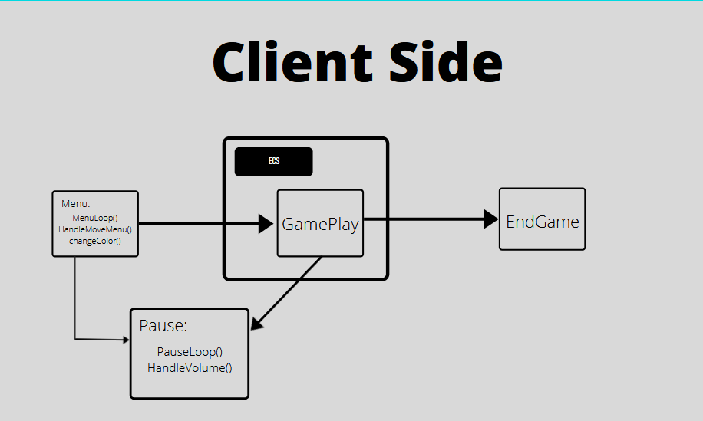

4- The ECS engine

The ECS is divided as its name suggests into three parts: Entity Component System.
An Entity is defined by the fact that it is something that could be described as concrete, physical, that it is possible to touch in real life. For the case of R-Type for example an Entity will be a vessel or even a enemie. The one if will compose of Component and the whole is managed by a System.
In our code an Entity corresponds to an id (std::size_t) and is managed by an entity manager containing a signature array (std::bitset). The position of a signature in the array corresponds to the id of the entity to which it is assigned.
Each bitset lets you know which Component is present in which Entity.
A Components represent a data, something that is not concrete

Finally The system manages what has been described previously, it contains a std::set that stores the entitys it must manage.

To know which entitys go into which system, one assigns particular components to the system, and this one will manage all the entitys containing the components in question.
Each part of the ECS is managed by a manager, and the 3 managers work together thanks to a 4th manager who serves as coordinator.

